Big Idea - Cloud Chime

I propose an interactive message unit which allows you to communicate through senses, movement, sound and light with friends and family one to another across the globe to keep in touch, to feel emotionally and socially connected in this heavy technology driven lonely 21st century. Smart interfaces and physical buttons are not present for the sole purpose to reduce the technology appearance aspects of the product - the concept of invisible technology, break away from smart interface with sculptural and playful exterior and embedded technology “hidden” inside.
Make it easy access to all age groups and any technology knowledge background. The user's experiences and content therefore become the most important part in this product. Aim to tackle the issue of loneliness in this heavy tech-driven era with colourful, light hearted, less technology focused and more user focused product to achieve the ultimate goal of raise one's quality of life and well-being.

Appearance – Cloud Chime
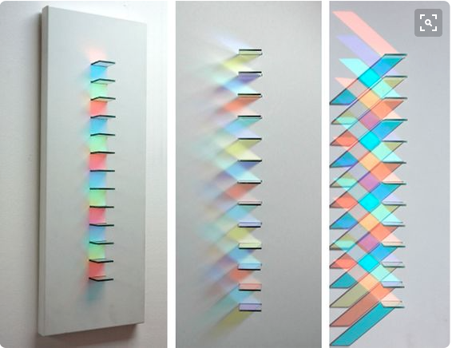
- The main factor is change by motion, colour, movement, sound and light

- The appearance of the product aim for the concept of being invisible, it appears invisible with the glass/transparent exterior when it's not being used, when interact with the product, light, movement and sound will make the product become “visible”

- LED laced wire as the structure of the 3D cloud shape exterior, glass exterior break up into small glass panels and metal pipe wind chime
attached below for “natural” sound effect Chris Wood, light artist

- Material - glass, wood and metal

Key Functions - invisible technology

- The wired structure are laced with LED light panels which switch on by heat sensor

- Kaleidoscope effect - The main interaction with cloud chime is the motion of touch/heat sensor (body heat) to turn on the LED wire and activate moving glass panels / indicate presence. Moving glass panels will create angels which reflect different LED lights to create different shades of colour

- Mimdsa pudica (shame plant) effect – Glass panel moving open/close motion adopt from shame plant moving motions, panels act randomly to create unique shades of light.

- LED and moving glass panel move simultaneously

- Wind chime controlled by moving motor which turns on by motion sensor of the moving glass panels, create sound effect.

